ET Case Processing for Trinity Emails

Overview
Trinity's policy validation emails are now processed as Email Triage (ET) cases, so claim handlers see the email chain directly on the TRI claim case. This design is implemented on Pega Constellation 25.1.3.
Problem. Claim handlers had to open the Attachments utility, download the Trinity email to their local disk and open it as HTML to read it.
Solution. Route Trinity replies through the OOTB ET case process. The ET case is linked to the TRI case, and the email display widget on the TRI case's Review harness shows the email.
Scope. Inbound Trinity replies: ET-to-TRI linking, attachment linking, AI extraction of the policy validation flags from the email body and moving the TRI case forward. Outbound triage is a future enhancement.

Previous approach vs ET approach
The ET approach replaces most of the custom listener logic with OOTB email channel behaviour, keeping only two targeted customizations.
Aspect | Previous approach | ET approach
Email account | Existing email account | TrinityEmailAccount (Save As of the existing account)
Listener | Standalone listener ReadTrinityEmail | Listener auto created by the TrinityEmailAccount email channel
Case creation | None; email handled directly against TRI case | ET case created and updated OOTB
Attachment parsing and linking | Custom, done manually in the listener | OOTB, saved on ET and linked to TRI
Email visibility | Download attachment and open as HTML | Email display widget on the TRI Review harness
ET-to-TRI linking | Not applicable | Custom (OOTB check bypassed)
Email body extraction | Custom | GenAI connect ClaimValidationFlagExtractor during ET processing
Pushing TRI case forward | Custom, after linking | PushWorkCaseAhead from pyPostProcessTriageWork

Components
Every rule involved in the solution, with whether it is OOTB or custom.
Rule | Rule type | OOTB / Custom | Purpose
TrinityEmailAccount | Email Channel | Custom config | Reads Trinity replies; auto-creates the email listener
TrinityEmailAccount | Email Account | Custom config | Mailbox for Trinity; saved as from the existing account
pxCreateAndManageTriageWork | Activity (Service Email) | OOTB | Creates and updates the ET case
pyLinkByCaseIdFromSubjectEnabled | When | OOTB extension | Enables OOTB link-by-subject; not relied on (see below)
pyPreTriage | Flow | OOTB extension | Hook used to call the custom linking utility
LinkETWithServiceCase | Activity (utility) | Custom | Calls LinkETToServiceCase
LinkETToServiceCase | Function | Custom | Links ET to TRI without the operator email check
pyPostProcessTriageWork | Activity | OOTB extension | Hook for extraction and pushing TRI forward
PerformEmailExtraction | Activity | Custom | Calls GenAI connect and saves output on the case
ClaimValidationFlagExtractor | Connect Gen AI | Custom | Extracts policy validation flags from the email body
NeedSLAAdjustment | When | Custom | True when TRI case is in Awaiting Trinity Response
PushWorkCaseAhead | Activity | Custom | Adjusts SLA on TRI assignment
Data-WorkAttach-File, Link-Attachment | Data / Link classes | OOTB | Store attachments on ET and link them to TRI
Email display widget | UI widget on Review harness | OOTB | Shows the email chain on the TRI case

End-to-end process flow
Linking, GenAI extraction and the SLA push are custom; the rest is OOTB email triage.
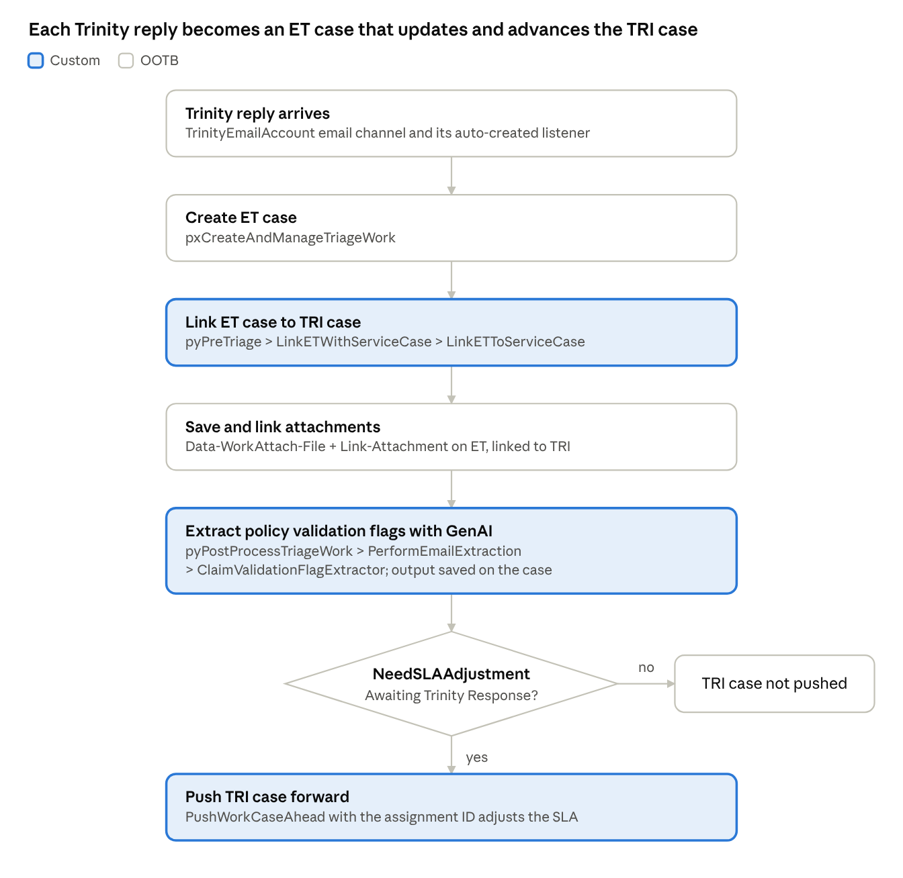
Inbound Trinity reply · 6 steps, 1 decision
Once the ET case is linked, the email chain is visible in the email display widget on the TRI case's Review harness.

Email channel setup
A new email channel and account handle all Trinity replies; the listener and ET case handling come OOTB.
- Create email account TrinityEmailAccount by doing a Save As of the existing Trinity email account.
- Create email channel TrinityEmailAccount pointing to this account.
- Saving the channel automatically creates its email listener. No manual listener setup is needed.
- The channel then creates updates and links ET cases OOTB via pxCreateAndManageTriageWork.
- The standalone listener ReadTrinityEmail from the previous approach is no longer needed for this flow.

Customization 1: Linking the ET case to the TRI case
We link ET-XXX to TRI-XXX with a custom function, because the OOTB link-by-subject logic never matches for Trinity emails.
OOTB behaviour. In pxCreateAndManageTriageWork, when pyLinkByCaseIdFromSubjectEnabled is true, the ET case is linked to the case ID found in the email subject. It only links when the sender (pyFrom) equals the email address of the TRI case's pxCreateOperator.
Why it fails. pyFrom is always hello@talktotrinity.com. The create operator is CS Guest User for webform cases, or a claim handler for portal cases. The two never match, so no link is created.
Custom solution. The Java linking logic from pxCreateAndManageTriageWork was copied into a new function with the operator email check removed. It is called once the ET case is created:
- pyPreTriage (extension flow)
  - LinkETWithServiceCase (custom utility activity)
    - LinkETToServiceCase (custom function)
Result. The ET case is linked to the TRI case, and the email shows in the email display widget on the TRI Review harness.

Attachments linking (OOTB, no change)
Attachments need no customization. Attachments in the incoming email are saved on the ET case as Data-WorkAttach-File instances with Link-Attachment records, created automatically. The same attachments are then linked to the TRI case automatically once the cases are linked.

Customization 2: Email body extraction and moving the TRI case forward
The policy validation flags are extracted with GenAI during ET processing, then the TRI case is pushed forward if it is waiting on Trinity.
What is extracted. Trinity fills a table of policy validation flags in the email body of its reply. The GenAI connect rule ClaimValidationFlagExtractor reads the body and returns these values.
Design choice. Extraction runs inside ET case processing, not on the TRI case, because the email body belongs to the ET case. It runs after ET and TRI are linked and attachments are linked.
Steps in the extended pyPostProcessTriageWork activity:
- Call PerformEmailExtraction, which invokes ClaimValidationFlagExtractor.
- Save the extracted output onto the case.
- Evaluate when rule NeedSLAAdjustment: is the TRI case in the Awaiting Trinity Response state?
- If true, call PushWorkCaseAhead with the assignment ID to adjust the SLA and move the TRI case forward.
- If false, the TRI case is left as is.

Future enhancement: Outbound triage
Explore the OOTB activity pxCreateOutboundTriageWork to create the ET case when the email to Trinity is sent.
- Today: the ET case exists only after Trinity replies, so the sent email is not visible until then.
- With outbound triage: the ET case is created right after sending, so claim handlers see the sent email in the email widget immediately. Trinity's reply then joins the same email chain.

